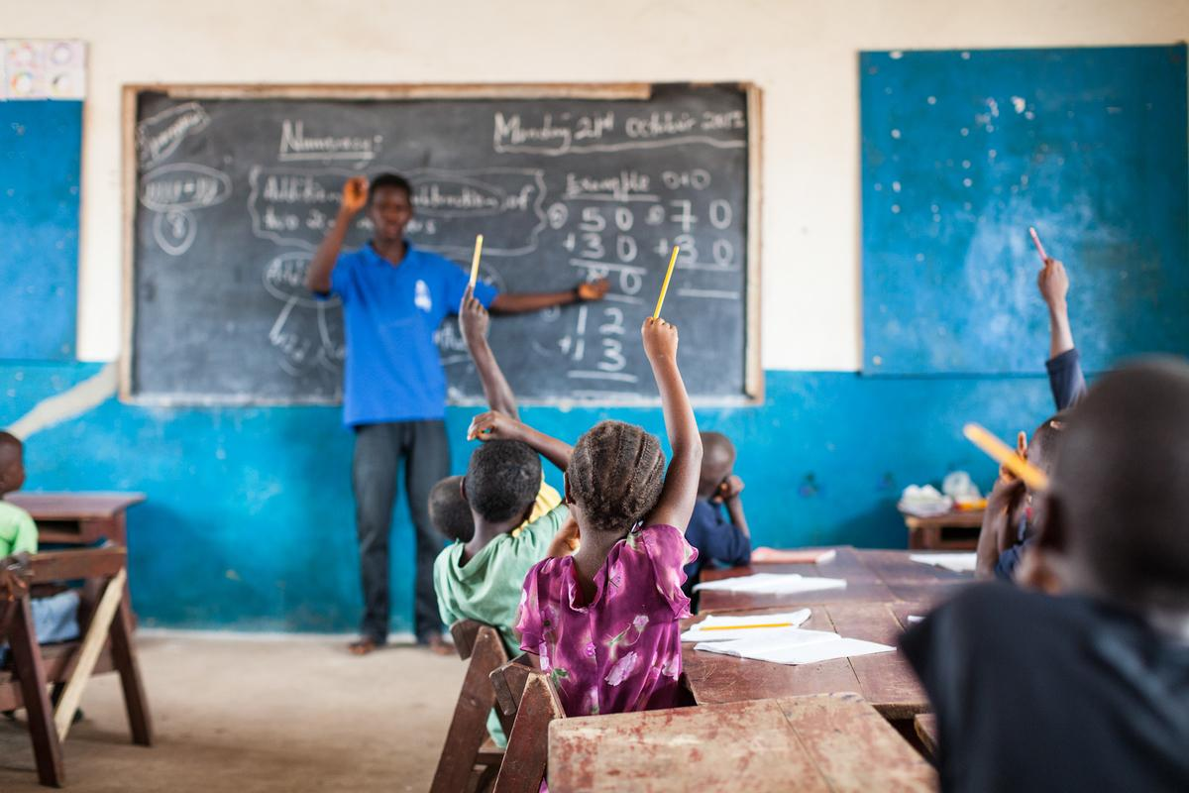

Photo credit: EducAid Sierra Leone

# Global Schools Forum

# Consultant (Part-time) – Coalition on childcare and economic empowerment of women

August 2025

# About Global Schools Forum

Global Schools Forum (GSF) is a **collaborative community of non-state organisations** working to improve education at scale for underserved children in low and middle-income countries.

Our **vision** is that all children can realise their potential through safe access to quality education.

The GSF community is the largest of its kind, including **177 organizations** spanning **71 countries,** collectively running or supporting close to **1.37M+ schools and school networks**, over 1.77mn teachers and providing education to well over **134M+ million children**.

Our community comprises **standalone schools**, such as [MAIA Impact](https://www.maiaimpact.org/) working with Mayan girls in Guatemala; **school networks** working within or across countries, including organisations like [Hippocampus](https://www.hippocampus.in/) working in India or [United World Schools](https://www.unitedworldschools.org/) working in Cambodia, Myanmar, Nepal and Madagascar; and organisations providing core support services to non-state schools, such as [EdPartners Africa](https://edpartnersafrica.com/) that provides financial services to schools in Kenya or [Instill Education](https://instill.education/) that provides a variety of teacher development offers across Africa.

# GSF’s strategy currently covers three core areas:

# Strengthening and growing a global, interconnected learning community. We are continuously expanding our community of mission-aligned, non-state organisations across Asia, Africa, and South America. We provide opportunities for our community of leaders to collaborate and learn from each other as they confront shared operational and pedagogical challenges. Based on the needs and challenges of the community, we curate an annual programme of events and communities of practice.

**Testing promising solutions and diffusing evidence.** We fund and support education entrepreneurs to develop, test and scale promising education approaches. We generate and share evidence on ‘what works’ in education and what makes organisations more effective.

**Partnering strategically to shape policy and scale solutions.** We enable our community to engage in the strengthening of education systems by engaging in global policy processes, and with support in forging partnerships with other organisations, funders, and policymakers.

We are a small, fully-remote global team with colleagues based in the UK and across Africa, Asia and Latin America, reflecting the communities in which we work.

Our Values are central to everything we do as a team, as a global community and in our engagements with partners, funders and the global education community:

* **Collaboration**: We leverage each other's strengths and knowledge to drive and amplify purpose driven collective action.
* **Intentional Inclusivity**: We cultivate and celebrate diversity of backgrounds, culture, perspectives, and approaches promoting inclusivity and mutual respect.
* **Continuous Improvement**: We commit to continuously learning, improving, and innovating, while sharing best practices and failures.
* **Honesty and Transparency**: We conduct ourselves with integrity, openness, accountability and kindness.

# Role Purpose

Access to affordable, quality childcare is a foundational investment with far-reaching benefits across societies and economies. It generates a “triple dividend”: facilitating [women’s entry and retention in the labour market](https://www.ilo.org/resource/news/closing-childcare-policy-gaps-offers-high-return-investment), supporting [children’s early development](https://www.cgdev.org/sites/default/files/impacts-childcare-interventions-LMICs.pdf), and generating [jobs in the care economy](https://www.gatesfoundation.org/ideas/articles/women-global-care-economy#:~:text=Beyond%20women's%20workforce%20participation%2C%20what,million%20women%20to%20the%20workforce.&text=Providing%20both%20universal%20child%20care,%2C%20and%20long%2Dterm%20health.). Childcare sits at the intersection of multiple development priorities - labour markets, gender equality, agriculture, health, education, and long-term social progress. Yet, despite the compelling evidence, it remains severely undervalued and fragmented.

Globally, more than [40 percent](https://www.worldbank.org/en/news/press-release/2021/03/04/nearly-350-million-children-lack-quality-childcare-in-the-world#:~:text=WASHINGTON%2C%20March%204%2C%202021%E2%80%94,in%20unsafe%20and%20unstimulating%20environments.) of all children below primary school age do not have access to childcare. Where services do exist, they often misalign with the working realities of families —offering restricted hours, poor quality, or unsafe environments. In many low- and middle-income countries, [high costs](https://voxdev.org/topic/education/realising-childcares-full-potential-low-and-middle-income-countries) further limit access, and [weak financing structures](http://report.educationcommission.org/wp-content/uploads/2016/11/Financing-ECD-Volume-I.pdf) prevent providers from improving quality or expanding reach.

The economic case for childcare is strong. [Research demonstrates](https://www.ilo.org/resource/news/closing-childcare-policy-gaps-offers-high-return-investment) that each dollar invested in closing the childcare gap could reduce the global gender pay gap from 20.1% in 2019 to 8% by 2035, and increase women’s employment from 46.2% to 56.5% globally over the same period. The benefits extend to men as well: [available evidence](https://voxdev.org/topic/education/realising-childcares-full-potential-low-and-middle-income-countries) suggests that childcare enables fathers or male partners to increase their labour supply and income and potentially secure more favourable employment.

The **social case** is equally compelling: quality childcare improves [children’s nutrition, health, and development, with regulated centres](https://pmc.ncbi.nlm.nih.gov/articles/PMC9915111/) offering stable routines, socialisation, and access to nutrition programmes that lower stunting rates. As social protection, it [shields children from neglect and unsafe environments](https://bettercarenetwork.org/sites/default/files/2020-12/social_protection_and_child_protection.pdf) while enabling caregivers to work or study, reducing vulnerability and breaking cycles of poverty.

Still, global childcare systems operate far below their potential, leaving significant social and economic gains unrealised. Scalability and sustainability are held back by critical gaps: Funding is fragmented, short-term, and lacks pooled or catalytic mechanisms to de-risk innovation; evidence and know-how are limited by the under-documentation of diverse, locally driven models; advocacy lacks policy salience, with childcare too often framed solely as a women’s issue rather than a driver of economic and social progress and finally partnerships are weakened by fragmented action and poor coordination across sectors.

To address these gaps, the coalition on childcare and women's economic empowerment has been launched as an ambitious 18-month initiative to define a shared roadmap for action. This initial phase will lay the foundation for a longer-term effort to expand access to quality, affordable care for **100 million children and families by 2030**, improving outcomes for women, children, families, businesses, and economies alike.

We are seeking a motivated and detail-oriented part-time consultant to support the design of the coalition. The consultant will play a key role in advancing this effort by contributing to research, documentation, partner engagement, and project coordination.

# Responsibilities

We are seeking a highly organised and proactive consultant to support the design and delivery of the coalition’s 18-month roadmap. The ideal candidate will combine strong research, writing, and coordination skills with the ability to work across diverse stakeholders, synthesise complex inputs, and translate them into actionable outputs. The candidate will be able to self-organise and deliver high-quality outputs against an agreed upon action plan.

The key responsibilities of the part-time consultant will be as below.

1. **Undertake landscape mapping and design stakeholder surveys:**

* Conduct desk research by reviewing key reports, frameworks, and materials shared by coalition members to extract insights that inform the coalition’s direction and outputs.
* Support consultation processes, including working group sessions, partner interviews, and targeted feedback rounds, to gather diverse perspectives to feed into the deliverables.
* Design survey instruments and landscape mapping tools for collection of data for the multi-country stakeholder survey and the mapping exercise.
* Develop a methodology to guide the analysis of findings from the landscape mapping exercise and the multi-country stakeholder survey.

1. **Data analysis and report writing:**

* Analyse findings from landscape mapping and stakeholder surveys to identify patterns, gaps, and strategic opportunities.
* Prepare deliverables on landscape mapping and stakeholder survey results in clear, shareable formats suitable for coalition review and external dissemination.

1. **Project coordination and partner engagement**

* Support the project lead in keeping workstreams on track by coordinating follow-ups, timely responses to partner queries, and monitoring progress against key deliverables.
* Draft clear, well-organised documents for internal use, including meeting notes, presentation decks, and briefing materials.

1. **Support coalition convenings:**

* Support in preparing background materials, agendas, and talking points to ensure coalition convenings are focused and well-structured.
* Capture and document key discussions, including decisions, insights, and action items, to support effective follow-up.

# Person Specification

If you are a results-driven professional with a passion for advancing childcare— and a proven ability to drive collaborative, cross-sector action — we want to hear from you. Join our team to help shape the coalition’s shared roadmap, building the critical foundation for a long-term effort that will expand access to quality, affordable care for millions of children and families worldwide.

**Knowledge, experience, and skills**

* 5+ years of experience in childcare, early childhood development, or international development projects.
* Experience in coalition-building, multi-stakeholder coordination, or network facilitation.
* Demonstrated ability to produce high-quality written outputs for diverse audiences, including policymakers, funders, and practitioners.
* Strong research and synthesis skills, with the ability to connect insights across sectors and geographies.
* Ability to analyse data to inform priorities and highlight evidence-based recommendations.
* Proven project coordination experience, ideally involving multi-country or multi-partner initiatives.
* Experience supporting high-level convenings, workshops, or consultation processes.

**Personal characteristics**

* Excellent organisational and communication skills
* Excellent interpersonal skills and ability to build and maintain strong relationships
* Ability to work with a diverse range of people across multiple time zones
* Excellent problem-solving skills and a hands-on attitude
* Ability to multitask and prioritize tasks effectively
* Adaptability and flexibility to the dynamic work environment
* Commitment to global education and shared belief in GSF’s vision

**Terms and Conditions**

**Fees:** Competitive within non-state education sector, adjusted based on location and experience.

**Contract**: 10-12 days a month for 10 months, with possibility for extension if project expands beyond the initial scope.

**Hours:** Part time, typically 9-5 in your time zone, but with significant flexibility. Given that we work across different time zones, some non-traditional hours for early or late calls may be required.

**Location**: Remote. Local work authorisation is required. Some local and international travel may be required. 

**Anticipated Start Date:**  As soon as possible.

**How to apply and application deadline:**

**Application deadline:** Applications will be evaluated on a rolling basis. Early application is strongly recommended.

**Please submit your application through our** [**career portal**](https://apply.workable.com/global-schools-forum/j/FA722366D3/)**.** You will need to upload your CV and a cover letter detailing:

* What excites you about GSF and this role in particular
* Your achievements and experience as they relate to this job description
* What you would do in this role to really make an impact

Please note, we will not consider any applications unless they include a CV, cover letter and response to the points above, and/or if they have not been submitted through our application portal.

**Recruitment Process:**

* Shortlisted candidates will be sent a written assessment to complete
* First-round interviews with Hiring Manager
* Final interviews with Senior Leadership

This is an immediate position. Applications will be reviewed on a rolling basis and may close early if a suitable candidate is found.

If you apply, we will process your personal data for recruitment purposes only and in accordance with our [Data Privacy Policy](https://globalschoolsforum.org/privacy-user-consent-privacy-notice-global-schools-forum).

**GSF is committed to cultivating a fair and inclusive workplace, where everyone can be themselves and thrive. We welcome applications from everyone regardless of race, age, disability, gender, ethnicity, sexual orientation or faith.**